Task No 01: Design a web page using Headings H1 to H6.
Input:
<html>
<P> There are six levels of heading in HTML. The lower the number, the larger the header will be. Thus, H1 is the largest header, and H6 is the smallest</P>
<h1> Heading 1</h1>
<h2> Heading 2</h2>
<h3> Heading 3</h3>
<h4> Heading 4</h4>
<h5> Heading 5</h5>
<h6> Heading 6</h6>
</html>
Output:
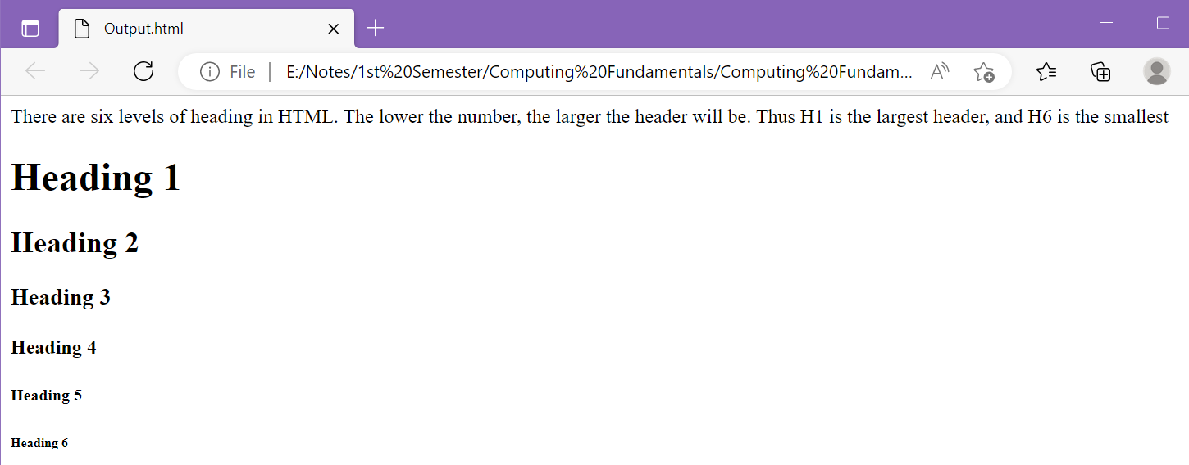
Task No 02: Design a web page using Center tag.
Input:
<html>
<h4><center>THE CENTER TAG</center></h4>
<P><CENTER>My Name is Abdullah sadiq.</CENTER></P>
</html>
Output:
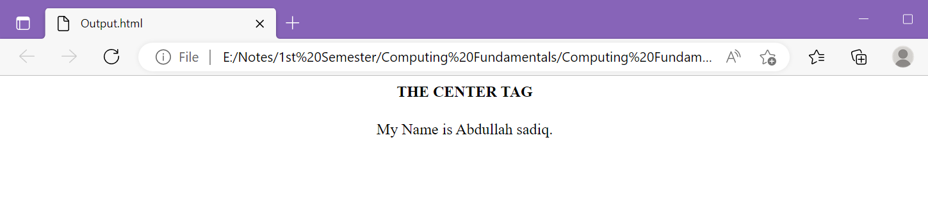

Task No 03: Create a Hyperlink and Navigate to it from your web page.
Input:
<html>
<h2 style="color:(black);font-style:normal"><center>ABDULLAH SADIQ</center></h2>
<P style="color:(black);font-style:normal"><center> -All the Social Media Handles- </center></P>
<p><center> <a href="https://www.instagram.com/as.captures._/?igshid=YmMyMTA2M2Y%3D">Instagram</a></center></p>
<p><center> <a href="https://www.facebook.com/AS.Capturess">Facebook</a></center></p>
<p><center> <a href="https://www.linkedin.com/in/iabdullahsadiq">LinkedIn</a></center></p>
<p><center> <a href="https://www.snapchat.com/add/iAbdullahSadiq">Snapchat</a></center></p>
</html>

Output:
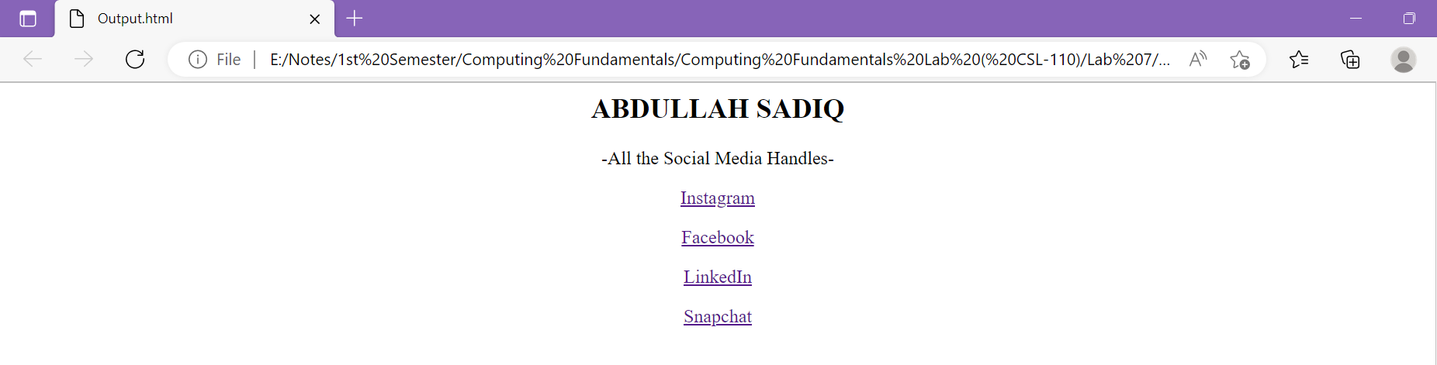
Task No 04: Design Tables using Row Span along with Table tag.
- Input:
<html>
<table border="1">
<tr>
<td>Num 1</td>
<td rowspan= "2" bgcolor="green"> Num 2</td>
<td>Num 3</td>
</tr>
<tr>
<td> Num 4</td>
<td> Num 5</td>
</tr>
</table>
</html>

- Output:
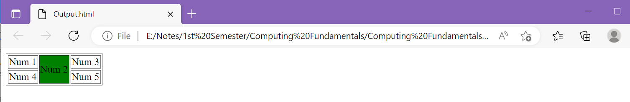
- Input:
<html>
<table border="1">
<tr>
<td rowspan= "2" bgcolor="green">Num 1</td>
<td> Num 2</td>
<td>Num 3</td>
<td> Num 4</td>
</tr>
<tr>
<td> Num 5</td>
<td> Num 6</td>
<td> Num 7</td>
</tr>
</table>
</html>

- Output:

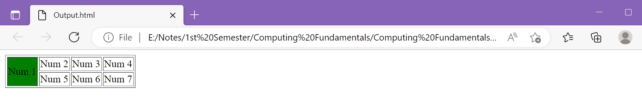
Task No 05: Design Tables using Col Span along with Table tag.
- Input:
<html>
<table border="1">
<tr>
<td>Num 1</td>
<td colspan= "2"> Num 2</td>
</tr>
<tr>
<td> Num 3</td>
<td> Num 4</td>
<td> Num 5</td>
</tr>
</table>
</html>
- Output:

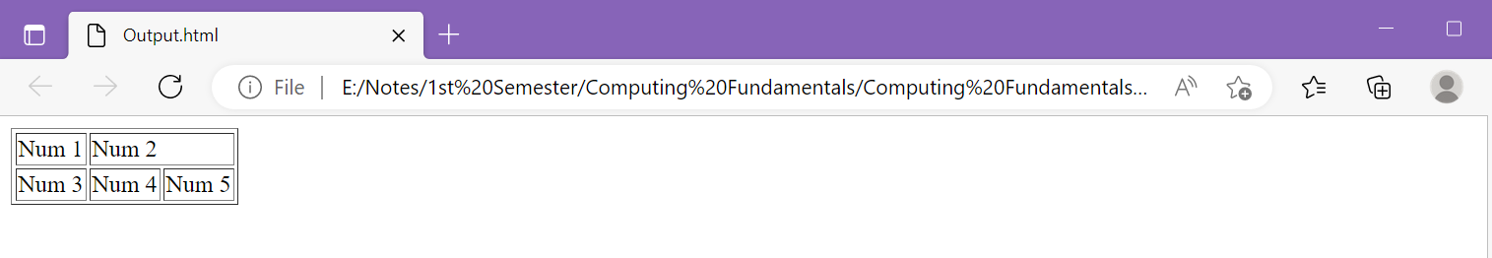
- Input:
<html>
<table border="1">
<tr>
<th colspan="2">Heading 1</th>
<th colspan="2">Heading 2</th>
</tr>
<tr>
<td>A</td>
<td>B</td>
<td>C</td>
<td>D</td>
</tr>
<tr>
<td>E</td>
<td>F</td>
<td>G</td>
<td>H</td>
</tr>
</table>
</html>

- Output:

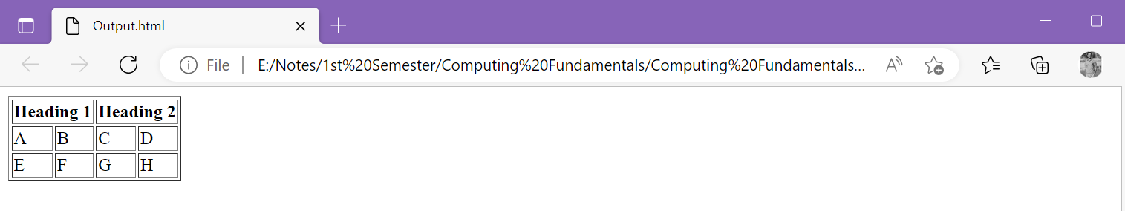

- Input:
<html>
<table border="1">
<tr>
<th colspan="2">Heading 1</th>
<th colspan="2">Heading 2</th>
</tr>
<tr>
<th>Heading 3</th>
<th>Heading 4</th>
<th>Heading 5</th>
<th>Heading 6</th>
</tr>
<tr>
<td>A</td>
<td>B</td>
<td>C</td>
<td>D</td>
</tr>
<tr>
<td>E</td>
<td>F</td>
<td>G</td>
<td>H</td>
</tr>
</table>
</html>

- Output:

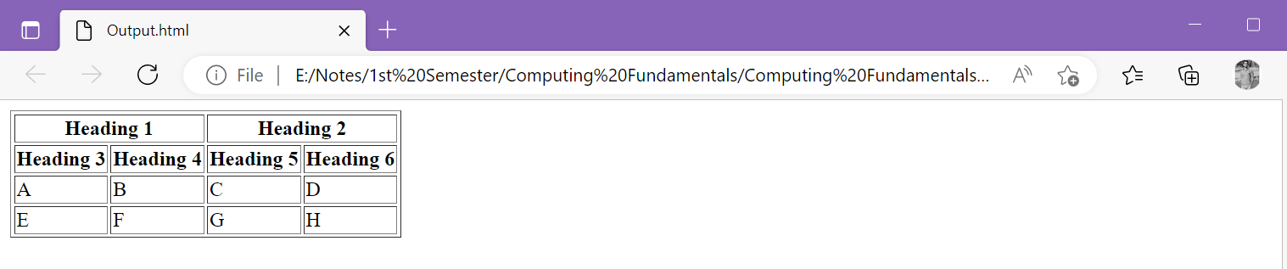

Task No 06: Design a Table using BG Color attribute, along with Row Span and Col Span.
Input:
<html>
<table border="1">
<tr>
<td rowspan="3" bgcolor="Pink">Pink</td>
<td colspan="3" bgcolor="Red"><center>Red</center></th>
</tr>
<tr>
<td bgcolor="Green">Green</td>
<td bgcolor="Yellow">Yellow</td>
<td>White</td>
</tr>
<tr>
<td colspan="3" bgcolor="Purple"><center>Purple</center></td>
</tr>
</table>
</html>

Output:
